****

**COMPANY PROFILE**

**YEAR: 2021**

**ALLIANCE OF THE CIVIL**

**SOCIETY FOR HUMAN RIGHTS**

**TABLE OF CONTENTS**

**ALLIANCE OF THE CIVIL SOCIETY FOR HUMAN RIGHTS (ACSHR)**

1. Our Team
2. Who We Are
3. Core values & principles
4. Vision
5. Mission
6. Aims & Objectives.
7. Approach of development
8. Focused areas
9. Organogram
10. Partners
11. Funding sources
12. Organizational strength
13. Governance & management instruments.
14. Organizational Experience
15. Photo Gallery

OUR TEAM****

Mr. Adv. Suhail Ahmed Qureshi Mrs. Fateh Panhwar Mr. Maqbool Ahmed Baloch

Legal Advisor Manager HR Finance Manager

**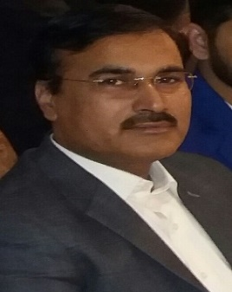**

Mr.Muhammad Ashraf Soomro Mr. Sajid Mehmood Mr. Ulfat Mehmood Khan Bangash

Chairman Head of Program Technical Advisor

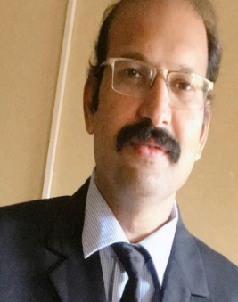

**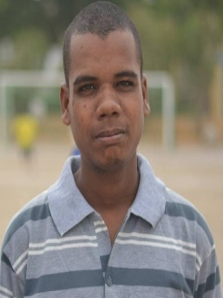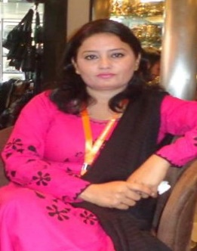**

**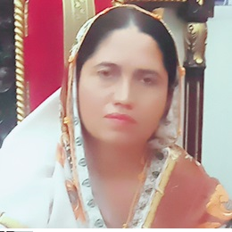**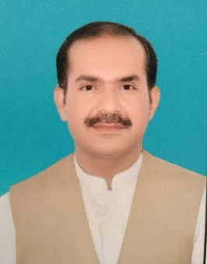**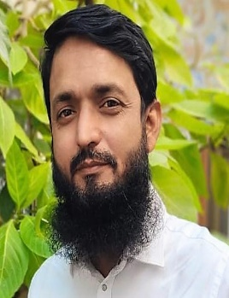**

Mr. Abdul Ghaffar Jamali Mr.Abdul Jabar Siyal Ms. Rukhsana Baloch

Program Manager Baluchistan Project Co-coordinator Administrative Officer

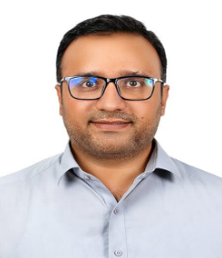

Mr. Syed Umaish Gul

Liaison Officer

**Who We Are**

**Alliance of the Civil Society for Human Rights (ACSHR)** is a national level of NGO. It was founded in February 2010 in Karachi. It is a Humanitarian and development organization by local Pakistani intellectual and community members. The purpose is to provide sustainable livelihoods intervention opportunities to support the most vulnerable communities both in urban and rural areas of Pakistan consequently will have access to better education, adequate primary health care and employment opportunities respect the ideals of human rights, peace, good governance and eventually improved sustainable community development.

The Organization is registered from the office of Sub-registrar of Gulshan I Iqbal town Karachi.

Subsequently to consultative meetings in Karachi, the founders responded to the urgent need of Pakistani people and made the platform named as Alliance of the Society for Human Rights (ACSHR).

ACSHR’s humanitarian and development intervention programs are holistic, people centered community based and sustainable. Therefore, sustainable livelihood approaches are adopted for all ACSHR strategic and short term programs.

ACSHR sustainable livelihood program interventions only add to the current humanitarian and development commitments in Pakistan by utilizing principally home ground solutions to vulnerable community challenges and needs. ACSHR corresponds to the existing international and national humanitarian and development strategies.

The Organization puts into operation participatory approaches, strategic planning and community mobilization to find solutions to community problems. It offers a range of programming and support in:

* Emergency Relief Response.
* Food Security and Livelihoods.
* Health.
* Formal Education.
* WASH.
* Youth Capacity Development Programs.
* Gender.
* Interfaith Harmony.
* Human Rights

Since inception, the organization was successful to implement a number of emergency and development projects in cooperation with the locals and international agencies. These projects benefitted a large number of the most vulnerable communities. It created credibility, good track record and close collaboration with all stakeholders. It has now transformed a well-established NGO competent of implementing multiple projects simultaneously.

**CORE VALUES AND PRINCIPLES**

* Respect the unique and inherent worth of all individuals.
* Moral and ethical integrity.
* Fairness and equality.
* Good governance.
* Honesty, transparency and accountability of stakeholders.
* Communication and collaboration.
* Environmental conscious.
* Independence.
* Solidarity with the poor.

**VISION**

ACSHR strives to ultimately see a stable and economical strong Pakistani society living in harmony, peace, good governance, rule of law, human rights and sustainable resource management.

**MISSION**

Improve and sustainable livelihood of vulnerable communities in Pakistan through environmentally sound interventions while focusing on human rights, equality, good governance, justice and democracy.

**AIMS & OBJECTIVES**

1. Reduce malnutrition and food insecurity that cause irreparable damage to livelihoods, thereby reducing self-sufficiency through introducing sustainable food security and livelihoods improvement initiatives.
2. 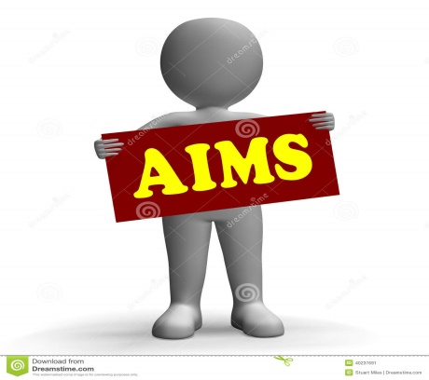Increase access to education for children from poor and vulnerable groups while strengthening the quality and capacity of teachers, teaching/learning environment and institutional structures.
3. Increased sustainable access to safe water and sanitation services for men, women and children in rural and urban.
4. Increase access to primary health care services to vulnerable groups and locations.
5. Increase public environmental awareness and advocacy through trainings, meetings, media etc.
6. Build the capacity of local CBOs, women groups, youth groups in better management practices, service delivery etc.
7. To enhance education and skills training access to youth and adults to promote employment opportunities.
8. Enhance peace building, human rights and democracy promotion.
9. Promote and advocate for gender sensitive approaches to enhance women’s rights and girl-child education and strengthen the participation and involvement of women and vulnerable groups in programs and organization.
10. Improve the protection of and respect for the human rights and dignity of vulnerable populations with a special focus on IDPs, women, children and marginalized groups through effective advocacy and the application of a rights-based approach across all sectors.

**APPROACH OF DEVELOPMENT**

ACSHR applies sustainable livelihoods approaches that provide a framework for addressing poverty and vulnerability in both development and humanitarian contexts. They have emerged from the growing realization of the need to put the poor and all aspects of their lives and means of living at the center of development and humanitarian work, while maintaining the sustainability of natural resources for present and future generations.

Sustainable livelihoods objectives aim to increase the sustainability of poor people’s livelihoods through promoting:

* Improved access to high-quality education, information, technologies and training and better nutrition and health.
* A more supportive and cohesive social environment.
* More secure access to, and better management of, natural resources.
* Better access to basic and facilitating infrastructure.

**FOCUSED AREAS**

**FOCUSED AREAS**

**WASH**

**AGRICULTURE & LIVELIHOOD**

**FORMAL EDUCATION**

**HEALTH CARE**

**NUTRITION**

**ADVOCACY**

**GENDER**

**CAPACITY BUILDING**

**INTERFAITH HARMONY**

**HUMANITARIAN RESPONSE**

**HUMANITY**

ACSHR focuses on the following core program areas:

1. **AGRICULTURE AND LIVELIHOODS PROGRAM**

Protect and improve household food security, including asset base, through increasing access and availability to food and means of production. Rehabilitation of agricultural sites and people associated with agricultural business.

**2. FORMAL EDUCATION**

* Increase enrolment and retention of school going population (aged between 5-18 years) with emphasis on gender equity and inclusiveness while address socio-cultural barriers that hinder the enrolment of girls and children with special needs through community mobilization and sensitization, and by combating violence in the school place.
* Facilitate the integration HIV prevention education for teachers, youth and children into education.
* Improve teacher competence through in-service training, mentoring and provision of basic incentives.
* Provide psychosocial training to teachers in emergency affected areas and psychosocial outreach to children through child-friendly spaces and integrate life-skills based approaches.
* Facilitate the availability of adequate and relevant basic education materials, kits and supplies.

1. **HEALTH CARE PROGRAM**

* Improve availability of and access to health care services for communities, with special focus on vulnerable groups such as women and children, through mobile clinics or strengthening of existing services, as well as through the promotion of health-seeking behavior.
* Improve quality of health care and treatment, including malnutrition with special focus on health infrastructure (physical equipment and supplies, including drugs for malnutrition treatment and human resource capacity).
* Improve health information management system to ensure availability of reliable data on the health status of the population.
* Ensure availability of health education material on prevention of targeted diseases (malaria, TB, AWD, HIV/AIDS).

1. **NUTRITION PROGRAM**

* The overall objectives is to lower the incidence of malnutrition avert excess mortality due to malnutrition and promote better nutritional status among populations in the affected areas.
* Initiate and facilitate intensive SFPs, including community-based nutrition actions, to the access of nutritionally vulnerable populations to emergency nutrition response.
* Promote appropriate infant and young child feeding practices.

1. **ADVOCACY PROGRAM**

* Effective advocacy with relevant stakeholders and parties to conflict to promote adherence to human rights law with emphasis on humanitarian concerns.
* Institutional capacity building of Government and civil society entities at all levels for effective prevention of and response to protection challenges with a particular focus on the most vulnerable.
* Human-rights based approaches are mainstreamed in the program design and delivery of all ACSHR programs.
* Community capacity enhanced for protection of the most vulnerable.
* Facilitate the availability of conducive environment for durable solutions for protracted displaced populations.

1. **WASH (WATER, SANITATION AND PROMOTION OF HYGIEN)**

* Increase access to sustainable water and sanitation services to reach the most vulnerable targeted areas and population.
* Increase awareness among target population and support in connection with safe environment and hygiene issues.
* Empower local community institutions and WASH authorities in target areas in managements of water and sanitation facilities.

1. **YOUTH CAPACITY BUILDING**

* To stimulate community development and transformation by offering the youth in the target area access to vital information and other basic educational activities that will raise their awareness about urgent development issues; and strengthen their participation and decision-making within the society on matters affecting their own lives.
* Establishment of centers to help the target youth groups, public and community-based organizations access affordable information technology services.
* Provide training facilities and assist establish youth forums, to enable them meet regularly, discuss, exchange and share ideas, learn about themselves and others. Understand their own problems, and identify their needs in relation to their existing social, political, cultural and religious structures, and take actions to direct and control their own future destiny.
* Discourage the youth from becoming members of armed militias, and organizations, with negative ideologies, by providing them with skills for alternative source of income generation including computer skills, entrepreneurship skills, enhancement of English language ability, management skills for youth organizations, leadership skills and learning of non-violent ways of living and resolving conflicts, through training, and appropriate reading materials.
* Encourage and assist the youth for equal opportunities to express their views, fully participate in development activities, and grow up with good human behaviors that can suit modern societies, on their own terms, through establishment of youth debate clubs, production of youth newsletter, magazines, entertainment facilities, and become updated by accessing appropriate information.
* Enhance the target youths’ knowledge and literacy levels by providing access to educational information and appropriate reading materials through well-equipped library services, reading clubs and audio-cassette listening forums etc.
* Enhance the academic English language performance of students at primary, secondary and tertiary institutions through access to reading materials, participation of inter-school debate clubs and reading clubs.
* Strengthen and enhance the capacities and performance of community- based youth organizations through accessibility to modern development books and materials, and training programs.

1. **GENDER**

* One of the realities that we need to remember and address is that, when women “trespass” in spaces that were previously completely male-dominated there is often a penalty. In education and in the workplace that backlash often takes the form of sexual harassment, humiliation, violence.
* Supporting women in non-traditional jobs is crucial in not only making long-lasting change in their lives but also help break social taboos.
* A proven way to overcome many systemic barriers to a woman’s success has been increased participation by women in local, regional and national legislation as empowered change agents.
* When mothers are educated and empowered to make choices in their lives, they enable their daughters to go to school.
* There has been much progress in increasing access to education, but progress has been slow in improving the gender sensitivity of the education system, including ensuring textbooks promote positive stereotypes.
* If we want girls to be able to complete education, we have to end child marriage. We also have to seriously address sexual harassment of girls.

1. **INTERFAITH HARMONY**

* Providing strategies and solutions for Inter-Faith Harmony in accordance with the Basic Islamic Sources.
* Create social awareness and improve collective common sense in the society regarding Inter-Faith Harmony.
* Develop mutual understanding among different religious sects of the society.
* Eliminate the sense of insecurity and injustice among the religious minorities.
* To ensure social justice and fair distribution of socio-economic resources.
* Create an environment of fore-bearance, tolerance and co-existence in the society.
* To suggest the actions and steps for the revival of Islamic concept related to Inter-Faith Harmony.
* Highlight the role of media in the promotion of Inter-Faith Harmony.
* Highlight the role of Universities, Religious Institutions, Governments, Religious Scholars, Civil Societies, Judiciary and Legislation Institutions to address the challenges to Inter-Faith Harmony.

1. **HUMANITARIAN RESPONSE**

* The ACSHR focuses on supporting the needs of people in Pakistan including refugees, facing a series of overlapping emergencies, including extreme weather events and the COVID-19 pandemic.
* The ACSHR has a multi-sectoral approach covering the themes of health, education, protection, food security, shelter, water, sanitation and hygiene (WASH), and refugees.
* The ACSHR also focuses on the lifesaving response activities including food security and livelihood assistance, nutrition programs, primary health services, including water and sanitation, women’s health, and education support, as well as shelter for displaced people.

1. **HUMAN RIGHTS**

The ACSHR is committed to emphasize respect for human rights and focuses on the following;

* Right to health
* Worker’s right
* Right of education
* Freedom of expressions
* Violence against women & girls.
* Freedom of religion & belief.
* Valuing diversity.

**ORGANOGRAM**

**PARTNERS**

ACSHR, in support of following partners, is working to gain the trust and confidence among the humanitarian actors in Pakistan and also trying to attract funds from various donor and INGOs. The partners include:



* + 1. Mubashir Bhutta Human Rights Organization
    2. Reformist’s Social Welfare and Development Organization
    3. Amnat Welfare Organization
    4. Development and Alternative Foundation
    5. Ansar Burni Welfare Organization
    6. Sindh Green Foundation
    7. HEAD Social Welfare Organization
    8. Khadmain-y-Sindh Foundation
    9. Karachi Social Welfare Organization
    10. Organization for the Welfare of special persons
    11. Aghosh Welfare Society and Development Association

**FUNDING SOURCES**

The organization strives to rise funding from both the international and local donors to sustain its objectives and activities. It has developed accountability and transparency mechanisms in conducting in its own projects. The organization has very strict financial management policy, systems and control mechanisms. It creates cooperation and working relationship with the local business people and the international donor agencies.

**ORGANIZATIONAL STRENGTHS**

ACSHR organizational strength lies within the skills, knowledge and experiences of its member organizations.

* Sound-vibrant and dynamic BOD and managing team.
* Dedicated experienced members and volunteers.
* Fully-equipped office in Karachi.
* Good relations and cooperation with the government, private and non-profit institutions.
* Support of well-wishers like renowned lecturers, doctors, teachers and professionals, etc.

**GOVERNANCE AND MANAGEMENT INSTRUMENTS**

ACSHR is having separate policies on the following issues:

* Human Resource [HR Policy]
* Board Governance Policy
* Volunteers Management Policy
* Financial [Financial Management Policy and Accounting System Guideline]
* Gender [Gender Policy]
* General Office Procedures
* Program implementation policy and procedures manual

**Organization Experience (Completed Projects)**

|  |  |  |  |  |  |  |
| --- | --- | --- | --- | --- | --- | --- |
| **S.No.** | **Project Title** | **Duration / Year** | **City** | **Funded By** | **Executed By** | **Status** |
| 1 | (IELP) Integrated Education Learning Programme Schools | 02 years | Tando Allahyar | Sindh Education Foundation | ACSHR | Complete |
| 2 | (IELP) Integrated Education Learning Programme Schools | 02 years | Karachi | Sindh Education Foundation | ACSHR | Complete |
| 3 | (IELP) Integrated Education Learning Programme Schools | 02 years | Jacobabad | Sindh Education Foundation | ACSHR | Complete |
| 4 | Independent Post Campaign Monitoring | 03 months / 2011 | Jhal Magsi | WHO | ACSHR | Complete |
| 5 | Distribution of Food and NFI Items | 03 months / 2011 | Jacobabad | Mubashir Bhutta Human Rights Organization | ACSHR | Complete |
| 6 | Citizen Voice Project | 06 months | Jacobabad | USAID | ACSHR in collaboration with WORDS | Complete |
| 7 | Mobile health unit | 01 year | Jacobabad | Mercy World-wide trust | ACSHR | Complete |
| 8 | FEMPOWER | 2021 | Quetta (Baluchistan) | Shirkat Gah | ACSHR in collaboration with Aghosh | Complete |
| 9 | Flood Victims Assessment | 2010-11 | Barkhan (Baluchistan) | BBSA | ACSHR in collaboration with Aghosh | Complete |
| 10 | Aser Survey | 2014-15 | Kohlu, Barkhan, Dera Bugti (Baluchistan) | Idara-e-Talim-o-agahi | ACSHR in collaboration with Aghosh | Complete |
| 11 | Women’s Empowerment Program through CNIC Registration in NADRA | 2012-13 | Kohlu | Aurat Foundation | ACSHR in collaboration with Aghosh | Complete |
| 12 | Strengthening Youth-Led Organization | 2013-15 | Quetta | CDA/UNDEF | ACSHR in collaboration with Aghosh | Complete |
| 13 | Justuju-My right my voice | 2015 | Quetta | CDA/Oxfam | ACSHR in collaboration with Aghosh | Complete |
| 14 | Strengthening and Engaging CSO in Public Accountability | 2015 | Quetta | AID Baluchistan / NED | ACSHR in collaboration with Aghosh | Complete |

**Organization Experience (On-going Projects)**

|  |  |  |  |  |  |  |
| --- | --- | --- | --- | --- | --- | --- |
| **S.No.** | **Project Title** | **Duration / Year** | **City** | **Funded By** | **Executed By** | **Status** |
| 1 | BBSHRRDB | 01 years | Karachi | Govt. of Sindh | ACSHR | On-going |
| 2 | Emergency Flood Relief | 3 months | Mirpurkhas | Govt. of Sindh | ACSHR | On-going |
| 3 | NFIs Distribution in 4000 Families at Dadu District | One Month | Mehar & KN Shah | Catholic Relief Services | ACSHR | On-going |

**PHOTO GALLERY**

|  |  |
| --- | --- |
|  |  |
|  |  |
|  |  |
|  |  |
|  |  |
|  |  |
|  |  |
|  | |
|  |  |
|  |  |
|  | |
|  | |
|  | |
|  |  |
|  | |
|  |  |
|  | |
|  |  |
| **Description: IMG_6336** | **Description: DSC00022Description: DSC00022Description: DSC00022Description: DSC00022** |
|  |  |
|  |  |

**FIND US**

|  |  |
| --- | --- |
| **HEAD OFFICE - KARACHI**  ADDRESS: A-104/1, SACHAL GOTH RESIDENCY, PCSIR SCHEME 33, DISTRICT EASTKARACHI.  PHONE: 0333-7335483, 0300-2575133, 0332-8786028, 0334-3667824  EMAIL: [acshr2021@gmail.com](mailto:acshr2021@gmail.com)  Website: [www.acshr.org.pk](http://www.acshr.org.pk)  FACEBOOK: ALLIANCE OF THE CIVIL SOCIETY FOR HUMAN RIGHTS | |
| **DISTRICT OFFICE – DADU**  FOCAL PERSON: MUHAMMAD ASHRAF  ADDRESS: HOUSE NO. 102, SOOMRA  MUHALLAH, PHULJI STATION,  DISTRICT DADU.  PHONE: 0333-7335483 | **DISTRICT OFFICE – BADIN**  FOCAL PERSON: RIZWAN ALI  ADDRESS: HOUSE NO. 08, ALI TOWN  BYPASS ROAD, BADIN    PHONE: 0333-7335483 |
| **DISTRICT OFFICE - SUKKUR**  FOCAL PERSON: SYED UMAIS SHAH  ADDRESS: HOUSE NO. D-516/133, MOLVI  ABDULLAH STREET NEAR NISHAT  CINEMA, BARRAGE ROAD, SUKKUR.  PHONE: 0334-3667824 | **PROVINCIAL OFFICE - QUETTA**  FOCAL PERSON: ABDUL GHAFAR JAMALI  ADDRESS: HOUSE NO. 51-OPPOSITE FATIMA  COMPLEX NEAR SAIGON RESTAURANT  PHASE-3 SHAHBAZ TOWN, QUETTA  PHONE: 0331-8051921 |

**THANK YOU**

